H.T No
Regulations:
A17


Sreenidhi Institute of Science and Technology
(An Autonomous Institution)
Code No: 6AC07 Date: 30-May-2019 (FN)

B.Tech II Year II-Semester External Examination, May/June-2019 (Regular)
CONTROL SYSTEMS (EEE)

Time: 3 Hours Max.Marks:75

Note: a) No additional answer sheets will be provided.
b) All sub-parts of a question must be answered at one place only, otherwise it will not be valued.
c) Missing data can be assumed suitably.

Part - A Max.Marks:25

Answer all QUESTIONS.

1. | What are the basic elements used for modeling mechanical rotational system? | [3M]
2. | Name the test signals used in control system. | [3M]
3. | How the roots of characteristic equation are related to stability? | [3M]
4. | What are advantages of frequency response analysis? | [3M]
5. | What is minimum phase system? | [3M]
6. | List advantages of state variable method over conventional one. | [2M]
7. | State Mason’s gain formula with necessary nomenclature. | [2M]
8. | List frequency domain specifications. | [2M]
9. | What is Nyquist plot? | [2M]
10. | Define acceleration error constant. | [2M]
Part – B Max.Marks:50
ANSWER ANY FIVE QUESTIONS. EACH QUESTION CARRIES 10 MARKS.

11. | a) | Differentiate Open loop and Closed loop control systems with suitable examples. | [4M]
 | b) | Find transfer function C/R for the following diagram using Mason’s Gain formula.  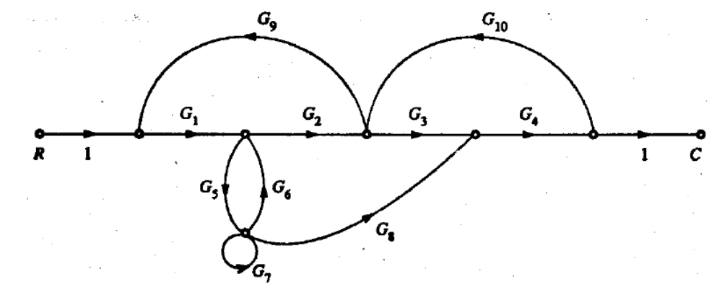 | [6M]
12. | a) | Define the following terms of second order “Under damped” System.  - Delay Time ii. Rise Time  iii. Peak time iv. Maximum overshoot  v. Settling time | [4M]
 | b) | For the system shown below, Find Kp, Kv and Ka, steady-state error for an input of  50u(t), 50tu(t) and 50t²u(t). Also state the system type.  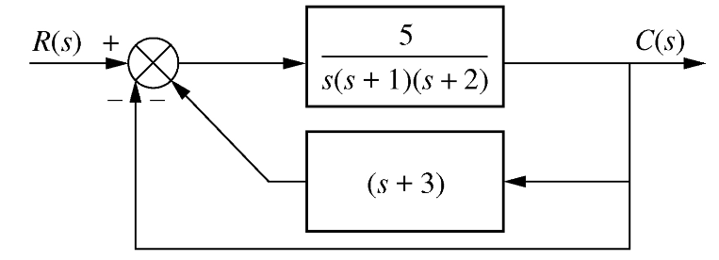 | [6M]
13. | a) | Using Routh criterion, determine the stability of the system whose characteristic equation is s⁴+8s³+18s²+16s+5 =0. Also determine the number of roots falling in the RHS plane and LHS plane. | [6M]
 | b) | Derive magnitude and angle criteria for stability. | [4M]
14. | a) | Define Bandwidth and derive relation for a standard second order system. | [3M]
 | b) | Sketch Bode diagram for the following transfer function and obtain the gain and phase cross over frequencies.  G(s) = 10/ s(1+0.4s) (1+0.1s) | [7M]
15. | a) | The open loop transfer function of a unity feedback system is  G(s) = 1/ s (1+s)(1+2s)  Sketch the Polar plot and determine the Gain margin and Phase margin. | [6M]
 | b) | Explain design procedure of Lead compensator using Bode plot. | [4M]
16. | a) | List properties of state transition matrix. | [3M]
 | b) | For the circuit shown below, write all modeling equations and derive the transfer function e₂/e₀. All initial conditions are zero. | [7M]
17. | a) | Write a note on Synchro as an error detector. | [4M]
 | b) | Define steady state error and explain how it is determined? | [3M]
 | c) | Explain the method of calculating the breakaway points. | [3M]
18. | a) | Define the terms:  - Phase crossover frequency  - Gain crossover frequency  - Phase margin  - Gain margin | [4M]
 | b) | State and explain Nyquist stability criterion. | [4M]
 | c) | Obtain characteristic equation of the matrix  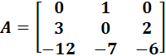 | [2M]

-- 00 -- 00 –

